EXPLORATORY DATA ANALYSIS REPORT
Fitness Market Analysis
LA Fitness Expansion Strategy Across Florida Counties
All 67 Florida counties | Census + Google Places + official gym pricing | OLS regression
Prepared for the MSIS Data Science Assignment | September 1, 2026

Observed demographics, locations, and official advertised price observations; transparent estimates only where no local offer was available

Purpose and Scope
This report examines the market structure of all 67 Florida counties before regression modeling. It combines official demographic measures, live Google Places results for LA Fitness and four competitor brands, and official plan-level advertised prices where public enrollment pages expose them. The objective is to identify distributions, relationships, and unusual counties that may affect model interpretation or expansion decisions.
Critical limitation: MembershipPrice uses official advertised recurring offers where locally available (32 counties) and a statewide median estimate for 35 counties without a local public rate. It is not a transaction-price survey; plan terms, promotions, and franchise differences limit comparability.

Data Collection and Preparation

Observed demographic inputs
- CountyPopulation: 2020 Census PL 94-171 total population (P1_001N).
- MedianHouseholdIncome: 2021 ACS five-year estimate (B19013_001E).
- LandAreaSqMiles: 2020 Census Gazetteer; PopulationDensity is population divided by land area.

Observed gym-market inputs
The Google Places Text Search pipeline issued branded, county-specific queries, filtered results to exact county and brand matches, and deduplicated by Place ID. The refreshed location file retains each gym's Google display name and formatted street address, along with coordinates, rating, and review count. It contains 428 locations across LA Fitness, Planet Fitness, YouFit, Gold's Gym, and Orangetheory Fitness.
Tracked brand | Accepted locations
Planet Fitness | 178
Orangetheory Fitness | 104
LA Fitness | 89
Gold's Gym | 11
YouFit | 46

Google Places results are a retrieval-time snapshot. Search relevance, closures, brand naming, and data coverage can change, so counts should be validated before a real estate commitment. Official pricing is also a retrieval-time snapshot of advertised offers, not a transaction-price survey.

Missing-Data Treatment
- Missing LA Fitness and competitor counts were set to zero after the county merge.
- 23 counties with no retained tracked-brand ratings received the statewide median Google Places rating. The completed MainDataset contains no missing values.
- Post-integration missing values in the analytical dataset: 0.

Descriptive Statistics
Variable | Mean | Median | Std. dev. | Minimum | Maximum
MembershipPrice | $49.66 | $43.99 | $10.97 | $14.08 | $79.00
CountyPopulation | 321,465.48 | 129,752.00 | 500,924.43 | 7,974.00 | 2,701,767.00
LAFitnessLocations | 1.33 | 0.00 | 3.21 | 0.00 | 16.00
CompetitorLocations | 5.06 | 2.00 | 8.88 | 0.00 | 45.00
MedianHouseholdIncome | $56,361 | $56,786 | $11,801 | $38,088 | $88,794
PopulationDensity | 384.49 | 188.16 | 574.10 | 9.54 | 3,504.16
AvgGymRating | 4.42 | 4.40 | 0.16 | 3.95 | 5.00

Required Visual Analysis
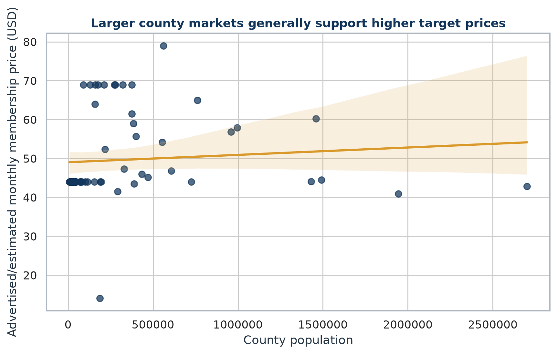
Figure 1. County population versus advertised/estimated monthly membership-price target.
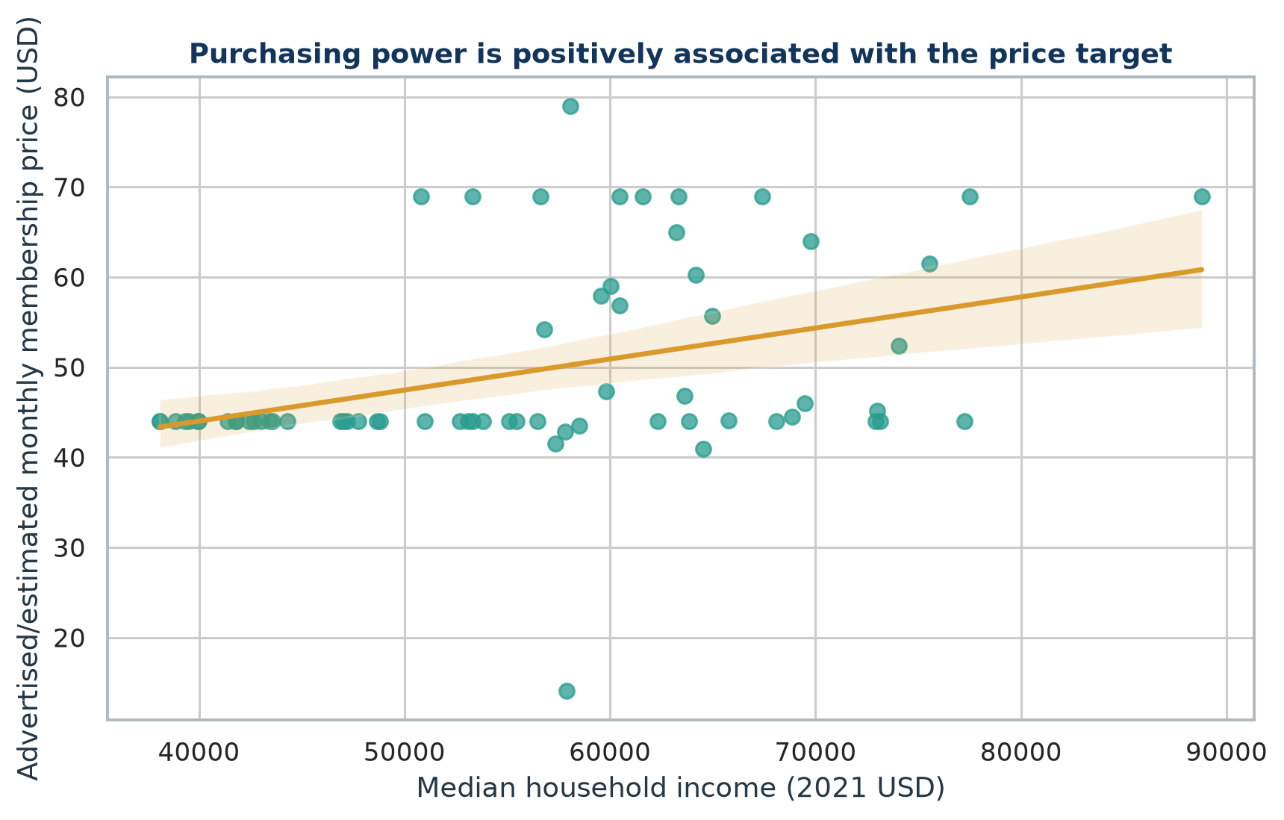
Figure 2. Median household income versus advertised/estimated monthly membership-price target.
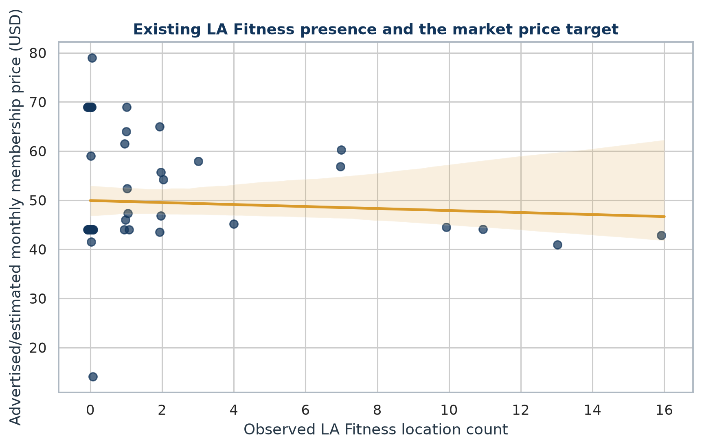
Figure 3. Observed LA Fitness location count versus the county price target.
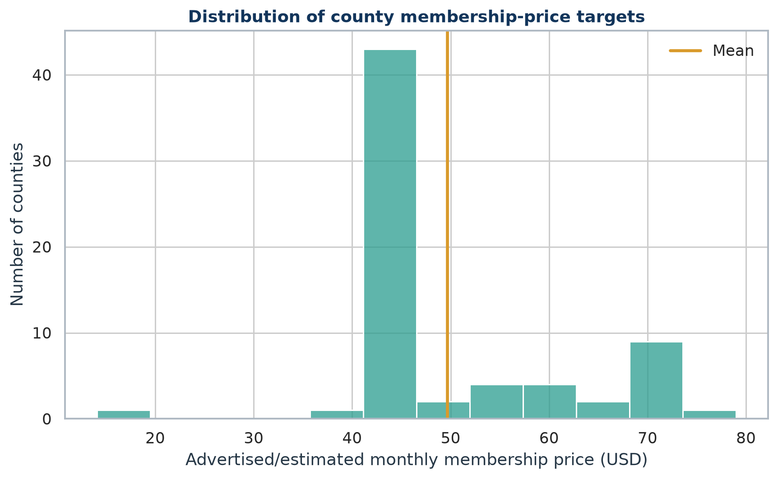
Figure 4. Distribution of county membership-price targets.
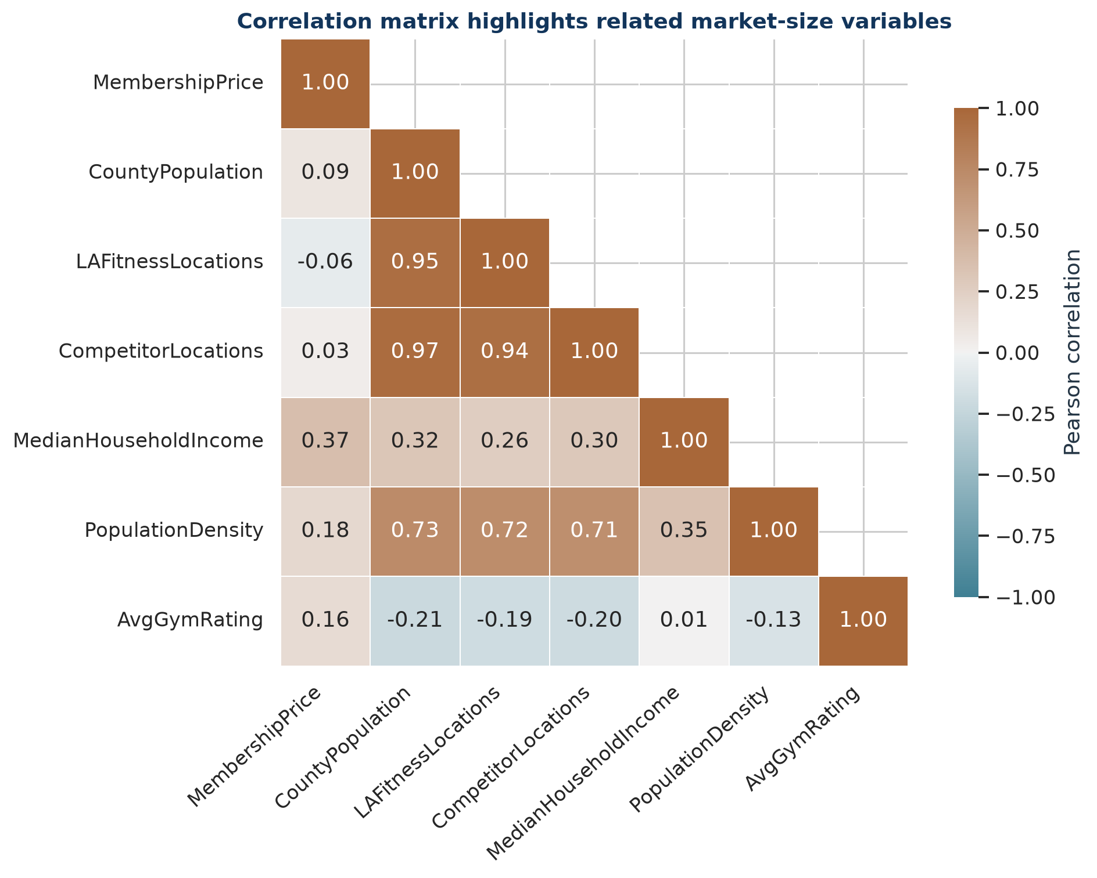
Figure 5. Pearson correlation matrix for all analytical variables.

Correlation Findings
- PopulationDensity: r = 0.180 (positive).
- LAFitnessLocations: r = -0.060 (negative).
- CompetitorLocations: r = 0.033 (positive).
- CountyPopulation: r = 0.086 (positive).
- MedianHouseholdIncome: r = 0.371 (positive and strongest).
- AvgGymRating: r = 0.157 (positive).
The market-size variables are also related to one another. This is expected because large, dense, affluent counties tend to support more fitness locations. Those relationships motivate the formal VIF check in the regression report.

Outliers and Business Meaning
- Population: Miami-Dade County is the largest county market at 2,701,767 residents, giving it disproportionate leverage in raw population relationships.
- Density: Pinellas County has the highest density at 3,504.2 residents per square mile, reflecting a different site-selection environment from geographically large rural counties.
- Purchasing power: St. Johns County has the highest 2021 median household income at $88,794.
- Influence diagnostics flagged Polk County, Pasco County, Charlotte County, Miami-Dade County. These counties deserve sensitivity review; a flag does not mean the data are wrong.

EDA Conclusions
- County markets differ sharply in size, density, purchasing power, and chain presence.
- The county price target is based on official recurring advertised offers in 32 counties; the remaining 35 counties use a transparent statewide median estimate because no local public rate was available. No predictor-based or random synthetic price formula is used.
- The 67-row dataset is complete and suitable for the required OLS demonstration, subject to multicollinearity and influence checks.
- Business use requires broader comparable local price coverage, a refreshed Places pull, and direct validation of candidate trade areas.

References
U.S. Census Bureau. 2020 Census Redistricting Data, Table P1, variable P1_001N. Source
U.S. Census Bureau. 2021 ACS 5-Year Estimates, Table B19013, median household income. Source
U.S. Census Bureau. 2020 Gazetteer Files and record layout. Source
Google Maps Platform. Text Search (New) documentation and pagination requirements. Source
LA Fitness. Public online membership signup flow with club-level plan options. Source
Planet Fitness. Official membership page with published starting monthly rates. Source
YouFit, Gold's Gym, and Orangetheory Fitness. Official Florida directories and public enrollment/studio pages. Source

